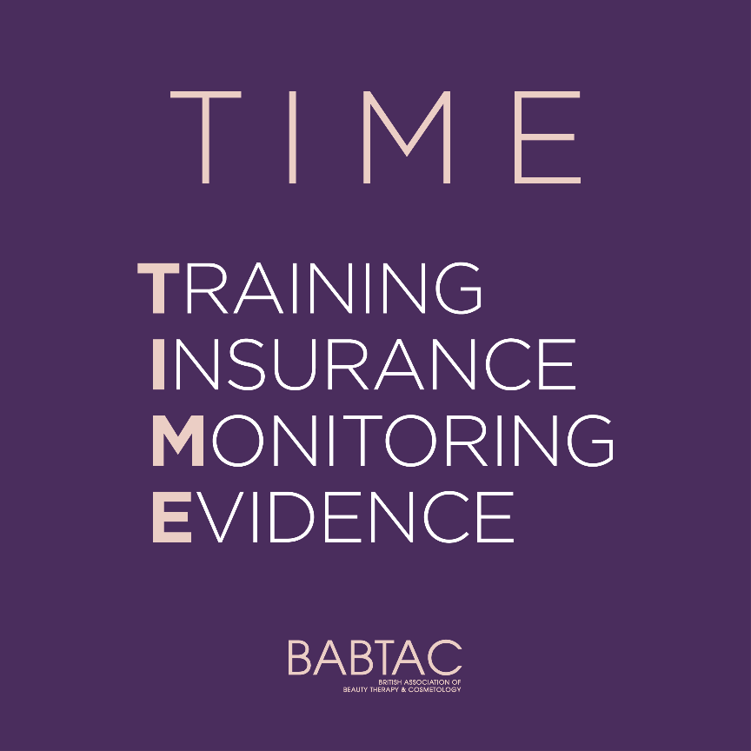

BABTACxTIME Initiative Launch - Suggested social caption

We’re proudly supporting T.I.M.E – a new initiative by @babtac, designed to help keep you, our clients, safe when booking beauty treatments.

Why? A lack of legislation in the UK beauty industry means there is nothing to stop someone with little or no training offering beauty treatments, which could lead to botched jobs and even potentially dangerous complications.

T.I.M.E is a regulatory checklist that you can ask to ensure your therapist meets a safe criteria and has proof of training, insurance and monitoring pre and post-treatment care.

TRAINING – What training and qualifications, including continual professional development (CPD) do you and all your staff have?
INSURANCE – Are you insured & who by?
MONITORING – Do you carry out important pre and post appointment processes such as patch tests, consultations & aftercare?
EVIDENCE – Can you provide certified proof of training and insurance and client testimonials?

We know it may be daunting to ask, but remember, any trusted professional will be more than happy to take the T.I.M.E to share this with you!

#BABTACxTIME

