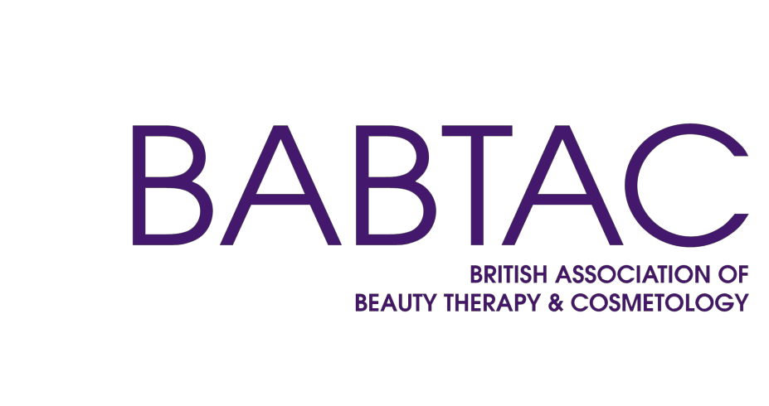

Short Course Accreditation

Additional Course Form



BEAUTY HAIR HOLISTIC CPD TRAINING

Application

Completing the form

Before submitting your application to BABTAC, please ensure payment has been made and all areas of the application have been completed. Supporting evidence should be sent with the application. The
application must be signed in order to secure your Short Course Contract.

Insurance & Qualifications
We need to see a copy of your current Public Liability and Teaching Insurance Certificate. You will be required to hold a valid full Membership with BABTAC. Corporate Teaching is also available with BABTAC. (please speak to our membership team for a discount).
If we are unable to provide the same level of Insurance cover, you will be able to stay with your current provider.
All tutors must hold a recognised qualification from an
awarding body in the subject that they wish to teach and a level 3 teaching qualification. All certificates will need to be sent along with the application form.
Titling of Courses
We need to approve your course title to make sure it fully reflects the course content and to ensure it reflects that this is a short course and not a qualification.
Scheme of Work
We will provide a template scheme of work for you to start planning your course - as an example. The course should be no longer than 7 days and no more than 30 hours. If
your course is less than 2 days a scheme of work will not be needed, a lesson plan will be sufficient.
Risk Assessment and Health & Safety
A Risk Assessment & Health and Safety Policy needs to be submitted before carrying out any accredited course. We will provide you with a Health & Safety policy guide once we have received payment.
Lesson Plan
We will also provide you with a template for you to begin planning your lessons, as an example. You should ensure that you have a separate lesson plan for each day that
you are running a course.
Course Manual
Your course manual should contain as much detail as possible and should mirror BABTAC’s idea of quality
driven training. Assistance will be provided throughout your application process.
Terms & Conditions
You should have a Terms and Conditions for your
business and this should be given to all students that attend your courses to read. These Terms and Conditions need to include a complaints policy and refund policy.
Equal Opportunities & Additional Policies
Once payment has been made, we are able to provide you with a guide for producing an Equal Opportunities Policy, Malpractice & Maladministration, Complaints Policy and a Refund Policy for your business.
Observation
The practical DVD needs to be 15 minutes long and needs to clearly show the method of teaching that will used and include a theory element.

Administration

Section 1

Date of application
Centre name

Staffing
Section 2
All tutors must hold a recognised Beauty Qualification from an awarding body in the subject they will be teaching, with at least 12 months experience and hold a recognised Level 3 Teaching Qualification. The
principle tutor must have Full Membership and Corporate Teaching with BABTAC. All additional Tutors must be current BABTAC Associate Members. This must be renewed every year to keep Accreditation active.

Name of Tutor | BABTAC Membership Number | Teaching Qualification | Work Experience

Short Courses

Section 3
Please complete the information below for the courses you intend to offer. Please refer to BABTAC short course structure document for recommended guided learning hours and pre-requisites required for BABTAC insurance purposes.

Course Title | Practical Hours | Theory Hours | Total Days | Tutor(s) | Pre-Requisites

Checklist
Section 4
Please check you have collected the required documents to complete your submission.

Required document | Centre check | BABTAC check
Completed application form
All tutor teaching certificate (s) (minimum requirement - Level 3 for all staff)
All tutor subject specific beauty qualifications (from recognised Awarding Body)
Scheme of work (If course 2 days or longer)
Lesson plan (For each day of training)
Completed course manual
End of course assessment materials
Observation (15 minutes of your chosen course)
Payment (Please note the below prices are inclusive of VAT, payments are non-refundable)
- £200 - per additional course

BABTAC office use only
Date payment received
Date checked
Target date issued after initial quality check

Section 5

I declare that the information in this application form is true and correct and agree to abide by the terms and conditions and BABTAC policies and procedures of the accreditation service and ensure they are positively and actively promoted and practiced.

Signature Print Name

Position in the Organisation Date

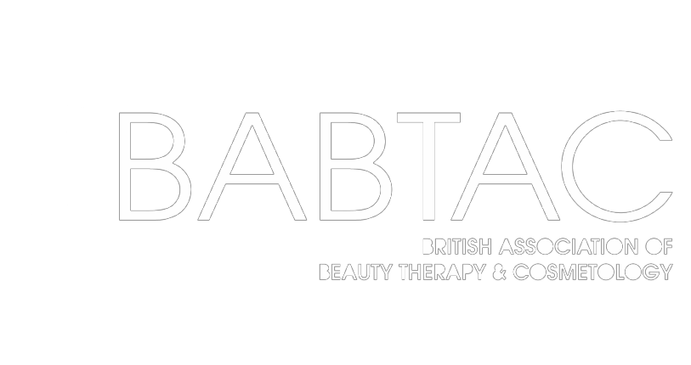

18c Ley Court, Barnett Way, Barnwood, Gloucester, GL4 3RT





sca@babtac.com
01452 623 110 (option 3)

