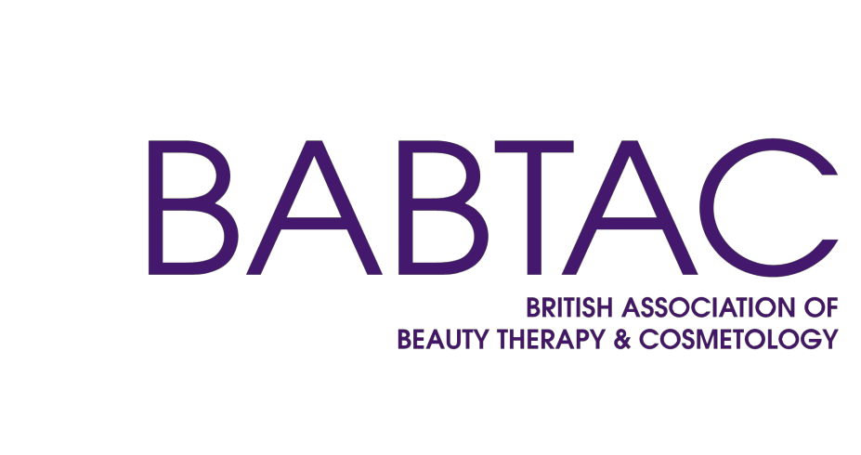

Short Course Accreditation

Application Form



BEAUTY HAIR HOLISTIC CPD TRAINING

Application

Completing the form

Before submitting your application to BABTAC, please ensure pre-application payment has been made and all areas of the application have been completed. Supporting evidence should be submitted with the application. The application must be signed in order to secure your Short Course Contract.

Insurance & Qualifications

We need to see a copy of your current Public Liability and Teaching Insurance Certificate. You will be required to hold a valid Full Membership and Corporate Teaching with BABTAC.

If we are unable to provide the same level of Insurance cover, you will be able to stay with your current provider.

All tutors must hold a recognised qualification from an
awarding body in the subject that they wish to teach and a level 3 teaching qualification. All certificates will need to be verified and submitted at the time of application.
Titling of Courses
We need to approve your course title/s to make sure it fully reflects the course content and to ensure it reflects that this is a short course and not a qualification. At no time can a BABTAC short course be marketed as a qualification.
Scheme of Work
We will provide a template scheme of work for you to start planning your course - as an example. The course should be no longer than 7 days and no more than 30 hours. If
your course is less than 2 days a scheme of work will not be needed, a lesson plan will be sufficient.
Risk Assessment and Health & Safety
A documented Risk Assessment & Health and Safety Policy is required before carrying out any accredited course. We will provide you with a Health & Safety policy guide once we have received payment.
Lesson Plan
We will also provide you with a template for you to begin planning your lessons, as an example. You should ensure that you have a separate lesson plan for each session that you are running a course.
Course Manual
Your course manual should contain as much detail as possible and should mirror BABTAC’s idea of quality
driven training. Assistance will be provided throughout your application process with consultancy available at an extra cost if required.. Any changes to this once accredited must be sent to BABTAC for approval.
Terms & Conditions
Terms and Conditions for your Business are required and this should be issued to all students that attend your courses to read and agree. These Terms and Conditions need to include a complaints policy and refund policy
Equal Opportunities & Additional Policies
Once payment is received, we will provide you with a guide for producing an Equal Opportunities Policy, Malpractice & Maladministration, Complaints Policy and a Refund Policy for your business.
Observation
The practical DVD needs to be 15 minutes long and needs to clearly show the method of teaching that will be used and include a theory element.

Administration

Section 1

Date of application
Centre name – please include legal name of the business and trading name, if different
Principle tutor address
Centre address
Centre telephone number
Mobile number
Email address
Website
Principle tutor
Contact name
Contact number

Is the centre located at the above address? If no, please give details. | Yes | No
Have you ever had any approvals turned down or withdrawn? | Yes | No
Have you registered with another awarding body? If yes, please provide details. | Yes | No
Where did you first hear about BABTAC?

Staffing
Section 2
All tutors must hold a recognised Beauty Qualification from an awarding body in the subject they will be teaching, with at least 12 months experience and hold a recognised Level 3 Teaching Qualification. The
principle tutor must have Full Membership and Corporate Teaching with BABTAC. All additional Tutors must be current BABTAC Associate Members. This must be renewed every year to keep Accreditation active.

Name of Tutor | BABTAC Membership Number | Teaching Qualification | Work Experience

Short Courses

Section 3
Please complete the information below for the courses you intend to offer. Please refer to BABTAC short course structure document for recommended guided learning hours and pre-requisites required for BABTAC insurance purposes.

Course Title | Practical Hours | Theory Hours | Total Days | Tutor(s) | Pre-Requisites

Resources
Section 4
It is a BABTAC requirement that you have the correct number of the following and it is sited correctly.
It is a BABTAC requirement to check that you have the highest standards of health and safety and can evidence this has been addressed to assist the safety of the learners accessing short courses.

Firefighting equipment, fire exits and fire doors | Yes | No
First aid boxes (fully equipped) | Yes | No
Up to date accident book | Yes | No
Active risk assessment policy (monitored annually or more frequently if required) | Yes | No
Electrical equipment tested annually | Yes | No
If no, please give details
Are fire evacuation procedures clearly displayed | Yes | No

It is a BABTAC requirement that all centres have the following:
- A practical salon room that can accommodate one workstation per candidate

- Easy physical access to all facilities and accommodation for candidates

- Sufficient hot and cold water, waste disposal, heating, lighting and ventilation

- Adequate hygienic toilet, hand washing and changing facilities

- A suitable area for theory sessions

- Equipment for sterilisation

Does your centre comply with all the above on the indicated site? | Yes / No

Checklist
Section 5
Please check you have collected the required documents to complete your submission.

Required document | Admin check | BABTAC check
Completed and signed application form
Final approved application form signed and dated
BABTAC terms & conditions signed
Public liability & teaching insurance certificate
BABTAC full membership & corporate teaching cover (for principal tutor)
Additional tutors BABTAC associate membership
All tutor teaching certificate (s) (minimum requirement - Level 3 for all staff)
All tutor subject specific beauty qualifications (from recognised Awarding Body)
Evidence of 12 months experience
COURSE MATERIALS
Course 1
Scheme of work (If course 2 days or longer)
Lesson plan (For each day of training)
Completed course manual
End of course assessment materials for both theory and practical
Assessment overview
Video of each course (15 mins max)
Additional Course 2
Terms & conditions of your business
Scheme of work (If course 2 days or longer)
Lesson plan (For each day of training)
Completed course manual
End of course assessment materials for both theory and practical
Assessment overview
Video of each course (15 mins max)
Additional further courses
Requirements as above
Your centre refund, complaints, risk assessment, malpractice maladministration policy & health and safety policy
Equal opportunities policy
Photo evidence of training centre
Payment (Please note the below prices are inclusive of VAT, payments are non-refundable)
- £100.00 – pre-application fee
- £240 - for one course
- £200 - per additional course
- £249 - yearly renewal
- £22 Per learner Certificate
BABTAC office use only
Date payment received
Date checked
Target date issued after initial quality check

Agreement
Section 6
I, the undersigned declare that the Centre understands that this is an enforcement agreement between the Centre and BABTAC. I further understand and agree that this agreement applies for a period of one year from the date of SCA (Short Course Accreditation) approval and that BABTAC has the right to issues updates and amendments to this agreement.
I accept that if the Centre defaults on the commitments made in this application it may lead to the termination of the agreement.
I declare that I am authorised by the Centre to supply the information given above and at the date of signing, the
information provided is as true and accurate record to the best of my knowledge. I further declare that I am authorised by the Centre to sign this agreement on behalf of the Centre.
The parties here to have caused this Agreement to be executed on the ‘proposed start date’, which will be confirmed by BABTAC in writing, subject to the Short Course Accreditation being successful. I agree to act in accordance with the requirements specified in this agreement.
Payment of the annual renewal fees is also acceptance of the T&C’s which attached with the renewal invoice

Signed for and on behalf of Centre:
Signed for and on behalf of BABTAC:
Signature
Signature

Section 7

I declare that the information in this application form is true and correct and agree to abide by the terms and conditions and BABTAC policies and procedures of the accreditation service and ensure they are positively and actively promoted and practiced.

Signature Print Name

Position in the Organisation Date

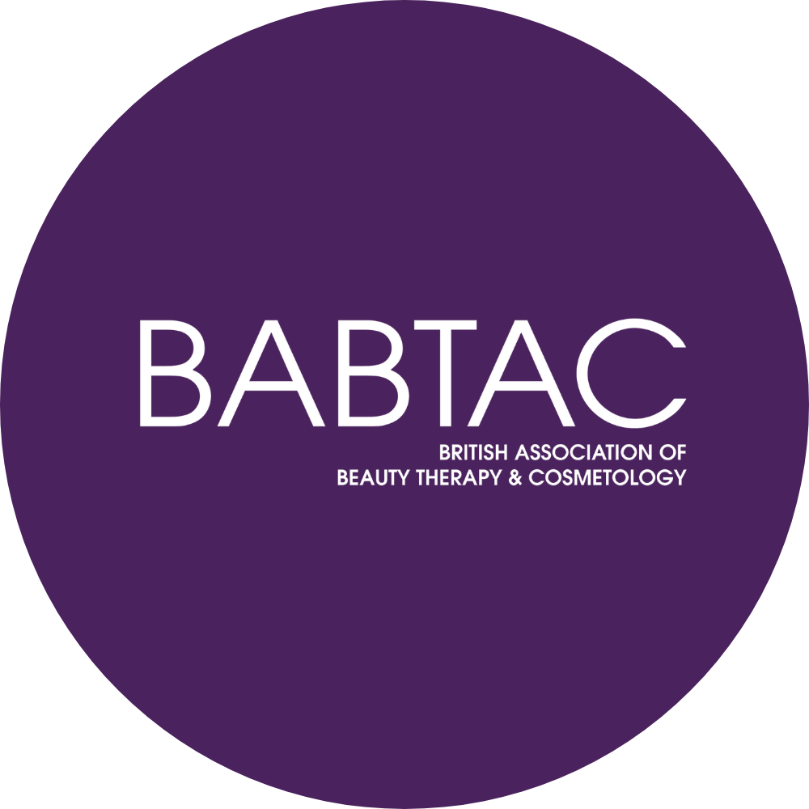

18c Ley Court, Barnett Way, Barnwood, Gloucester, GL4 3RT





sca@babtac.com
01452 623 110 (option 3)

